MODULE CODE: ATHE 5.1 CYBER SECURITY

NAME: FATIMA EJAZ BARRI

EMAIL: [mishalfatimaeb@gmail.com](mailto:mishalfatimaeb@gmail.com)

Topics given by tutor: Shahid Mustafa

# Difference between Symmetric and Asymmetric Encryption

* Symmetric encryption uses a single key that must be shared among the people who need to receive the message, while asymmetrical encryption uses a pair—consisting of a public key and a private key—to encrypt and decrypt messages when communicating.
* Symmetric encryption is an old practice, while asymmetric encryption is relatively new.

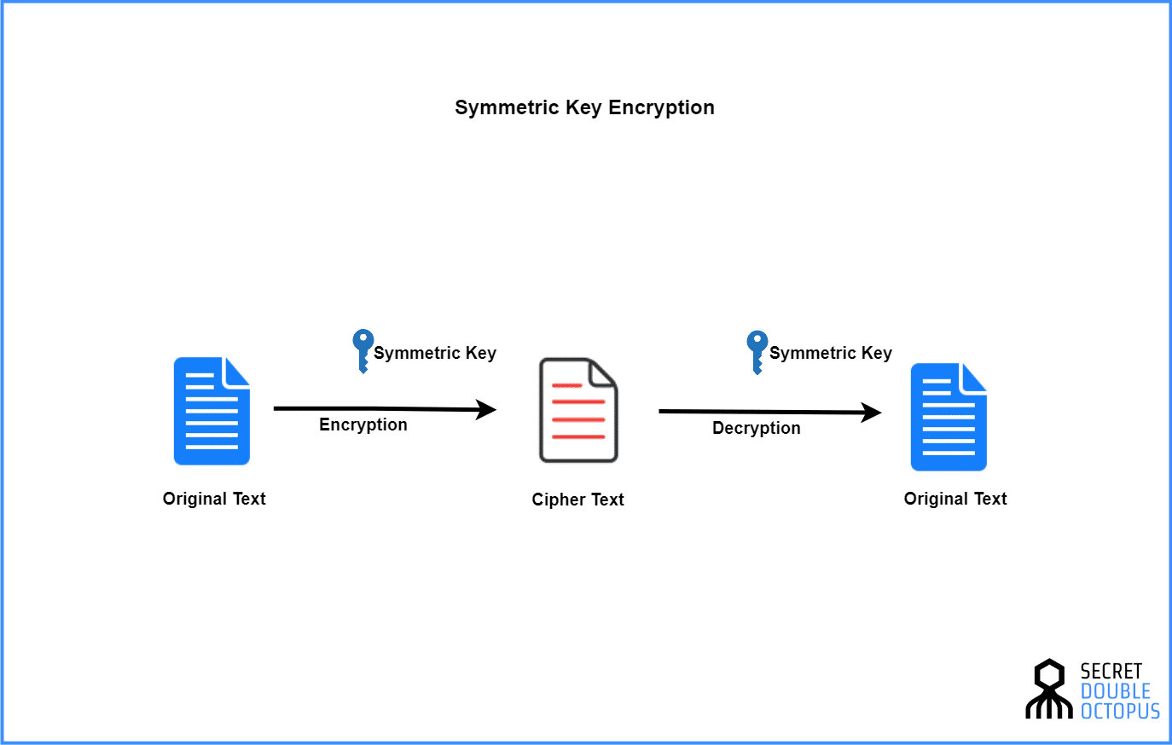

* Asymmetric encryption was brought in to fix the problem of the necessity of sharing the key in the symmetric encryption model, removing the need to share the key by using in its stead a pair of public-private keys.
* Asymmetric encryption eats up more time than the symmetric encryption.

[Symmetric encryption](https://www.cryptomathic.com/news-events/blog/differences-between-hash-functions-symmetric-asymmetric-algorithms) is a type of encryption where only one key (a secret key) is used to both encrypt and decrypt electronic information. This encryption method differs from asymmetric encryption where a pair of keys, one public and one private, is used to encrypt and decrypt messages.